**MUHAMMAD-HAMMAD**

**BCS-213064**

**Lab Task**

**-:QUERIES:-**

1: select max(salary) as Maximum,min(salary) as Minimum,sum(salary) as sum, avg(salary) as average from employees;

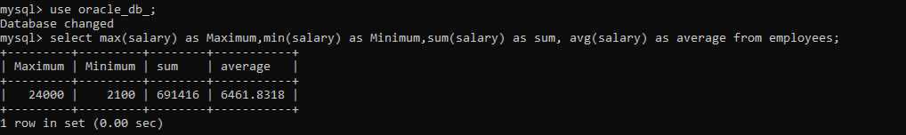

2: select job_id, max(salary) as Maximum,min(salary) as Minimum,sum(salary) as sum, avg(salary) as average from employees group by job_id;

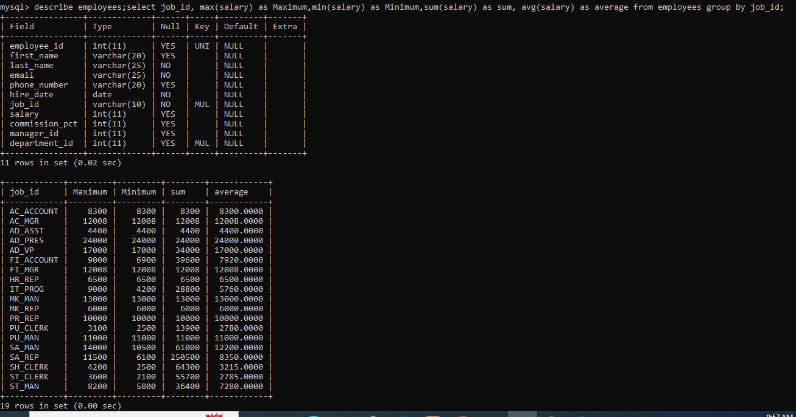

3:select job_id, max(salary) as Maximum,min(salary) as Minimum,sum(salary) as sum, avg(salary) as average from employees group by department_id;

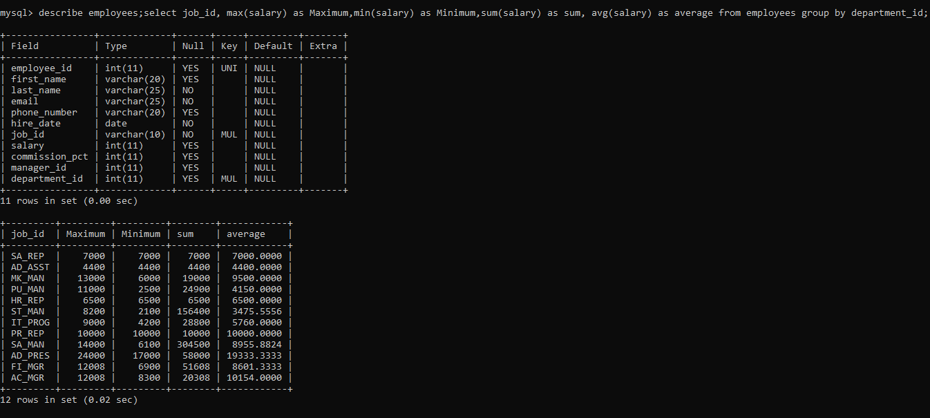

4: select department_id from employees group by department_id having avg(salary)>5000;

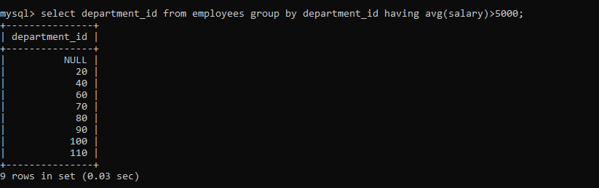

5: select department_id salary from employees where (salary>5000 and salary<50000) group by salary;

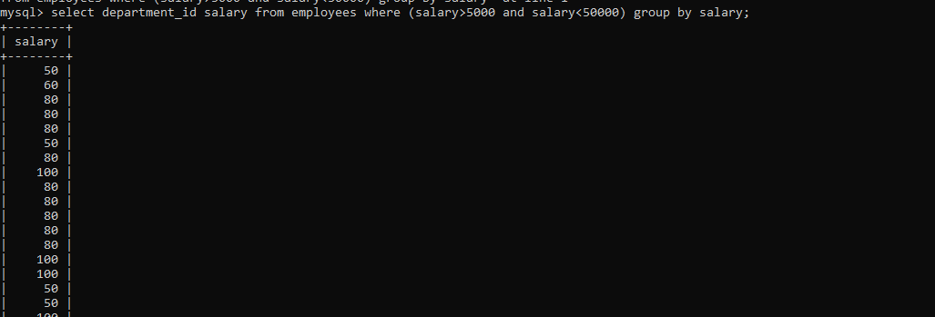

6: select employee_id , job_id, count(employee_id) from employees group by job_id;

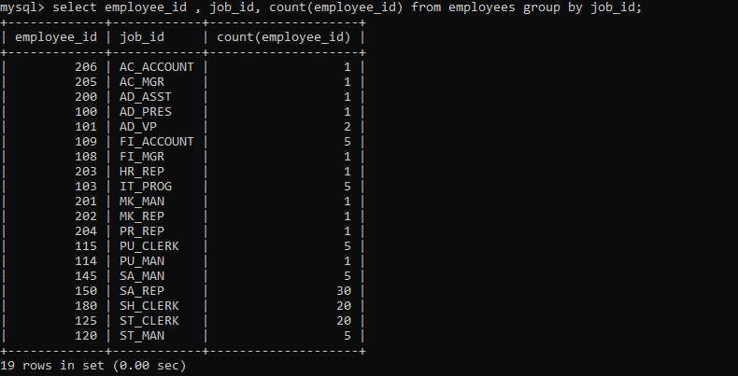

7: select manager_id, salary, min(salary),max(salary) from employees group by manager_id;

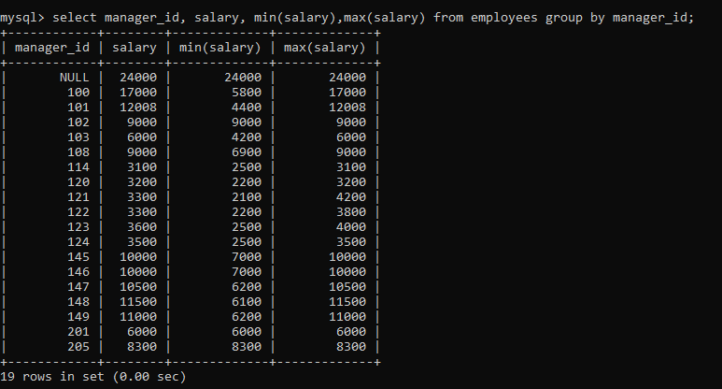

8: select country_id,city,count(city) from locations group by country_id having count(city)>2;

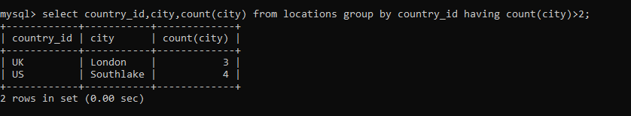

9: select job_id,job_title,count(job_id) from jobs group by job_id;

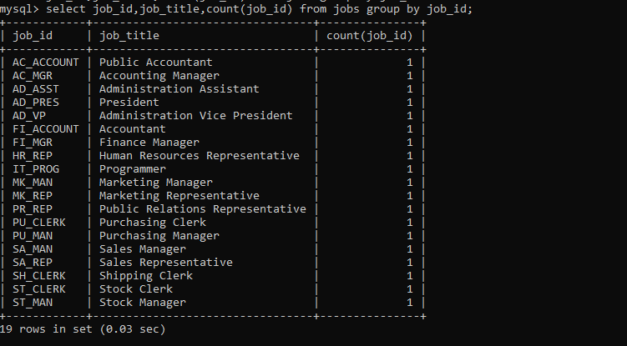

10: select region_id,country_id,count(country_id) from countries group by region_id having count(country_id)>5;

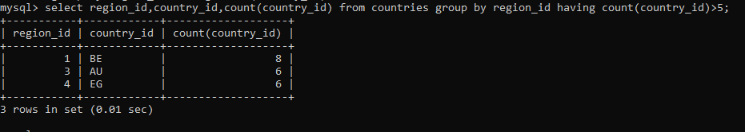

UN-SEEN TASK

**US1:**

Show first name of all of the employees who were hired in the department of 'IT' and 'SALES' in every year. Also show count of hiring for each year.

**QUERY1:**

SELECT FIRST_NAME, COUNT(*) FROM EMPLOYEES WHERE DEPARTMENT_ID IN ('IT', 'SALES') GROUP BY EXTRACT(YEAR FROM HIRE_DATE), FIRST_NAME;

**US2:**

Show names of all of the cities in every country and also show the count of the cities in every country.

**QUERY 2:**

SELECT c.name AS Country, ct.name AS City, COUNT(*) AS City_Count FROM country c INNER JOIN city ct ON c.code = ct.countrycode GROUP BY c.name, ct.name ORDER BY c.name;